Casa Libelula

Dragonfly House Spain

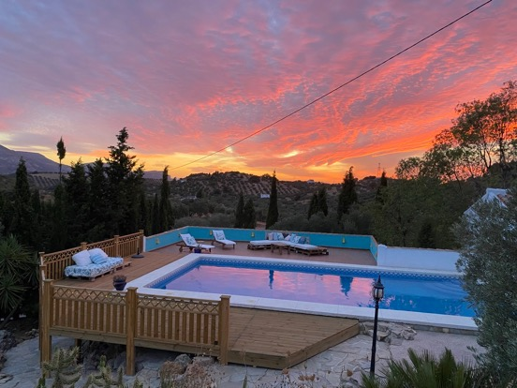

Retreat Centre near Antequera, Malaga, Spain

CONTENTS

Thank you for your interest in Casa Libelula, Dragonfly House Spain 4
1. Our offering to you 5
2. What we ask of you 5
2. Prices 6
3. Accommodation 6
3. Catering 7
4. Transport 8
4.1 Air Travel 8
4.2 Car Hire 8
4.3 Parking 8
4.4. Malaga airport transfers 9
4.5 Local transport 9
4.6 Minibus Hire 9
5. Onsite Massage and Healing 9
6. Marketing 9
We love to help people promote their retreats and are happy to do so for you on our Facebook and Instagram accounts. We will add your retreat to our website and can link to your own page for payments and/or we can take bookings and payments on your behalf free of all charges. 9
If you need a hand with some simple graphics, we can also help you put those together. We also can guide you towards some feminine marketing techniques, so your clients are magnetized to you, and you invite them in. Take a look on our website to see how our other clients have made use of this option. https://www.casalibelulaespana.com/reatreat-bookings/ 9
7. Insurance 10
8. Safety 10
9. Legal notes 11
10. WIFI and Telephone 11
11. Payment and Refunds 11
13. Floor Plans and Bedroom Descriptions 14

Thank you for your interest in Casa Libelula, Dragonfly House Spain

We are genuinely delighted you have asked to know more about this magical retreat center.

We exist because we believe in the power of people to find their way back to love. For many that means seeing the illusion in the world around us. We know that individuals arrive at the truth in many ways and here at Dragonfly House our mission is to wholeheartedly support those who are brave enough to take the steps needed.

We provide a powerful and protected healing space, designed with, and bought to life with passion, perseverance, and patience. We work in partnership with all our retreat hosts to support you in creating the atmosphere you want for your retreat.

From the sheets on the beds, to the food prepared in our kitchen, to our beautiful yoga and meditation spaces, everything here is done with the intention of giving you the sanctuary your guests need to relax, heal, and grow.

Where does your money go? Once our bills are paid, our buildings lovingly maintained and our team rewarded for their hard work on your behalf, our profits go to Lewa Wildlife Conservancy. Lewa serves as a safe refuge for the critically endangered black rhino in Kenya (we love chubby unicorns). We are also saving to open Dragonfly House Uganda to support the equally endangered White Rhinos.

The remainder of this document gives all the details you need. We have been as clear as possible and apologize if it seems a little formal in places. We believe good relationships are built on good communication and clarity; we want to build a good relationship with you from the very beginning.

If you have any questions, we love to speak with like-minded souls, so please don’t hesitate to reach out and arrange a time to connect with us. We want to know about you, the style of retreats you host and what would make it really special for you during your stay here…, so if you haven’t already, send us some details so we can get excited about you being here soon.

With Love,

Casa Libelula, Dragonfly House Team xxx

1. Our offering to you

We will make sure you and your students are taken care of and nourished while you stay with us. We will exclusively provide you with an inspiring environment and the space and equipment you need to run the retreat you have envisioned. We want you to allow us to hold you and your students safely in our accommodation and feed you whole healthy food that nourishes you in every way.

We will keep Dragonfly House clean, tidy, safe and in good working order to the very best of our ability. We retain the appropriate insurance for the house, the grounds and its use as a healing arts and retreat centre.

We set the best of intentions and put in maximum effort and positive energy to our work. As real human beings we allow our team the space to try new things, to learn new skills and grow which means sometimes we aren’t perfect and nor would we want to be!

Our place is a working olive farm in the heart of nature, and Mumma nature has her own powerful idea of how our environment will be used on any given day, things sometimes break or come to the end of their useful life, things constantly evolve and change here, our power and water sometimes goes off, the farming can be noisy sometimes. We live comfortably in the wild and are inviting you to join us and enjoy the experience mother nature wants you to have whilst you are with us.

Our home, ways of living and service are given in love, and with an open heart of generosity and sharing.

2. What we ask of you

We believe strongly we can only ever be responsible for ourselves, and our essential condition of you staying with us is that you follow this guidance and give it to the students and guests you choose to attend your retreat.

In choosing to stay with us, you and your students are agreeing to be fully responsible, respectful and legally liable for your own actions, words, physical well-being, medical health, safety, treatment of Dragonfly House, respect for each other and your possessions whilst staying with us.

We invite a relationship of trust and are trusting you with a home we love. We also trust you will tell us what we need to do or provide to give you the most supportive retreat experience. If you inform us in good time, we will always do our best to accommodate your needs. Please keep in mind we are in Spain and “manana” is a real phenomenon, things happen more slowly here than other places in the world so please give us as much advance notice as you can.

We are the guardians and protectors of Dragonfly House and the land it sits on is sacred to us. We ask you honour it and respect it as we do. It is a very special healing place, and we will always do what is needed to ensure it stays that way.
Payment of any kind enters you into this agreement with us.
The rest of this document contains lots of details. We know your guests will have questions so provide the rest of this information for your reference, but all is flexible and can be discussed if it doesn’t feel right to you.

2. Prices

Accommodation and full board catering priced 100 Euro per person per night.

Accommodation only costs 50 Euro per person per night.

A single supplement is charged when a person does not wish to share a room of 30 Euro per person per night.

3. Accommodation

During your stay you will have access to:
- 9 double or twin bedrooms
  - 4-bedroom Farmhouse with four ensuite bathrooms, open plan kitchen and double aspect lounge. Three bedrooms can be configured as double or twin rooms, one as a king-size double.
  - 3-bedroom Hill house with 3 ensuite bathrooms. All bedrooms can be configured as double or twin rooms.
  - 2-bedroom Guest house with shared Moroccan style bathroom, open plan kitchen and lounge. Both bedrooms can be configured as double or twin rooms.
- Large 50 square meter swimming pool.
- 5 terraces for dining, reading and sun lounging.
- 75 square meter studio, overlooking the olive grove.
- 7m diameter circular 360-degree view hilltop yoga and meditation deck.
- 13,500 sqm olive farmland.
- Outside fire-pit (recommended use October to April)

- The minimum number of nights stay is 1 but that won’t be long enough and is a lot of laundry for us, so we highly recommend you stay much longer.
- Check in and out is flexible where we can make that possible. If we have a retreat following yours, we ask you check out at 12:00 and if we have a retreat before yours you can join us from 15:00.
- Our maximum accommodation capacity is 18 people in our buildings with 12 more glamping spots available from Spring 2023.
- We don’t have a minimum group size but if you think your retreat will be on the smaller side speak to us so we can make sure our setting meets your needs.
- All bedrooms have air conditioning units that heat and cool the air.

For your comfort we also provide:
- A continuous supply of teas and coffee and a range of milks.
- Unlimited filtered water.
- Fresh fruit.
- Bathroom essentials including hand soap, toilet paper and a hairdryer.
- 1 bath towel, 1 pool towel and 1 hair towel per person.
- Once weekly linen change.
- Twice weekly bedroom cleaning.
- Daily cleaning of communal areas.
- Free Wi-Fi access.
- 20 indoor yoga mats for use in the studio
- 12 outdoor yoga mats for use on the meditation deck.
- 20 belts.
- 20 blocks.
- 20 bolsters.
- Studio sound system.
- 4m wide projector.

3. Catering

We offer a complete vegetarian or vegan menu consisting of:

- Breakfast – e.g., juice, fresh fruit, croissants, toast, butter, jams, cereals, muesli, yoghurt, tea & coffee. Hot breakfast e.g., eggs benedict.
- Brunch or lunch – your menu is seasonal and will be agreed with you 1 week in advance of you arriving with us. This can be taken as a packed lunch if the whole group selects this option.
- Afternoon tea - tea, coffee and cake or savoury snack. This can also be taken away packed for the whole group to enjoy.
- 2 course dinner - your dinner menu is seasonal.

You might also want to consider:

- Optional meat or fish supplement of 10 Euro per person per day.
- We highly recommend alcohol free retreats and are not licensed to serve alcohol. If you choose to offer alcohol to your guests, please let us know and we can provide chilling facilities and local purchase on your behalf.
- Mealtimes can be flexible around your schedule and if you are running over on your sessions, we do our very best to serve at the perfect moment you are ready. Please let us know your schedule so we can plan our time in the kitchen.
- Soft drinks and ice cream are available for purchase onsite using an honesty system. Your guests are required to note what they consume and settle their bill at the end of their stay.
- Our Dragonfly Guest Form asks your guests about special dietary requirements, preferences or allergies, and ideally, we receive this from all your guests 1 week before you arrive so we can plan your menu and shop accordingly.

Alternatively, if you select our accommodation only option, you can self-cater. We can help with advice on where best to shop locally for the best most ecological produce and even do your shopping for you in advance of your arrival. Our kitchen is well stocked with essentials, we ask you replace what you use or reimburse us for shopping on your behalf.

4. Transport

4.1 Air Travel
- The nearest airport is Malaga (AGP) 50 minutes’ drive via A45 or A46 (toll road).
- The nearest alternative airports are in Granada (1hr 30 mins drive), Gibraltar (2 hr 15 mins drive) and Seville (2 hr 30 mins drive).

4.2 Car Hire
- You and your guests can easily hire a car from the airport and make your own way to the retreat centre giving you the freedom to explore the region at your own pace during your stay.
- We recommend this option as we are 10km (15 min drive) from Antequera, our nearest town but it is not essential.
- There is very limited car hire in Antequera.
- We encourage guests hiring cars to include roadside assistance in their hire package. The roads in the area are country roads and potholes and loose surfaces are common.

4.3 Parking
- We have adequate parking for up to 9 cars and can provide overflow parking in the olive grove if needed.

4.4. Malaga airport transfers
We can arrange a transfer for 3 passengers per car with reasonable luggage space per person for approximately 90 Euro each way. Minibus taxis may also be available for larger numbers of passengers wanting to travel together. Prices will be confirmed with you in advance and may vary based on fuel price changes, we aim to provide you with a service that is as economical as possible for you.

4.5 Local transport
- Local car transport can be provided at 40 Euro per hour for both driving or driver waiting.
- Taxi transport is available locally.

4.6 Minibus Hire
If you require a minibus and driver for your stay this can be arranged on request and charged by the day. Prices are provided on request.

5. Onsite Massage and Healing
We have a skilled team and also know some great local healers. If you want your guests to enjoy these additional services to compliment your program, please let us know so we can help with arrangements. These additional therapies can be paid for in cash or by transfer at the end of your retreat stay.

- 60-minute Thai massage 70 Euro
- 30-minute Thai massage 45 Euro
- 30-minute Reiki Session 50 Euro
- 90-minute Experiential Healing session £111 (see website for details).
- 60-minute Ayurvedic oil massage with sound healing, prices and arrangement on request.
- 30–60-minute group sound healing (prices on request)

6. Marketing

We love to help people promote their retreats and are happy to do so for you on our Facebook and Instagram accounts. We will add your retreat to our website and can link to your own page for payments and/or we can take bookings and payments on your behalf free of charge.

If you need a hand with some simple graphics, we can also help you put those together. We also can guide you towards some feminine marketing techniques, so your clients are magnetized to you, and you invite them in.

Take a look on our website to see how our other clients have made use of this option. https://www.casalibelulaespana.com/reatreat-bookings/

7. Insurance
- We hold full building and public indemnity insurance to a value of £2million pounds.
- We recommend as retreat leader you are covered with appropriate insurance for the activities you guide your guests in.
- We also recommend you suggest your guests take out their own individual travel insurance covering them for the types of activity they will undertake on the retreat and the event they can’t travel due to illness (including Covid-19 or variant strain).

8. Safety
- Our pool is large with a 1m deep shallow end 2m deep end. There are no lifeguards (although Helen used to be but hung up her red swimsuit a while back now…) We ask you to be safe by the pool, and usual pool safety guidance is applied.
- Parents and guardians are responsible for children and young people (under 18 years of age) in their care while with us at all times, please be super vigilant as they can be drawn to the poolside.
- Between October and April, you can make use of our outdoor fire pit. Please let us know and we will ensure a member of our team can be present with you, we provide logs for your use.
- The farmhouse has wood burning fire. You can use this all year round.
- Please let us know of any issues or breakages within the property, or of fixtures and fittings so we can maintain a high standard for you.
- Very occasionally we see a snake and funnel web spiders here on the property, most are no bigger than a shoelace and harmless. We recommend guests to wear shoes when outside and take care exploring our gorgeous countryside.
- A member of staff will be on site or no more than 10 minutes away from site should you need us, and each day we will be present taking care of the buildings and gardens.
- We ask you keep in mind that we do have some (distant) neighbors and noise travels very well in the mountains. We suggest after 11pm and before 7am to keep the volume lowered.
- Staying hydrated is super important here, we highly recommend having a water bottle on your recommended packing list.
- We ask you to let us know if you or someone in the group aren’t feeling well and we will always do what we can to ease things for you, but you remain responsible for yourself and your body.
- In any emergency we will do as we believe is best, outcomes we leave to the universe and ask you acknowledge the same.

9. Legal notes

- Under Spanish Law, we are registered as a Casa Rural, and we are required to inform the local police of the names of guests staying with us and their passport, TIE, DNI, or NIE numbers. You can provide these details to us in advance, as can your guests if you wish or we can take down details on arrival. We have to submit the details within 24 hours of the start of your retreat.
- Our agreement is legally with you as the retreat organiser/leader not with your individual guests.

10. WIFI and Telephone
- Our WIFI is provided by satellite direct to the property. We are in a country setting and occasionally experience power cuts or a temporary loss of signal. We do our best to maintain a consistent electricity supply and WIFI signal but cannot guarantee a consistent unbroken provision.
- Mobile phone signal on our land is intermittent. We encourage guests to use WIFI based calling. We can help you access the right applications to make this possible however do not provide a wired telephone service.

11. Payment and Refunds
We only want to take payment in exchange for the space and services we provide to you. We have up-front costs including food and staff accommodation and so ask payments are made in advance of your retreat commencing.

- We are happy for you to use our website to receive your guest payments, we provide you a unique booking link free of charge and simply need from you some words and an image to represent your retreat. As guest payments come in, we can transfer these in full straight to your account if you prefer or retain what we are charging you per person for your stay.
- The balance of your retreat costs are ideally paid 1 week before the retreat commences. We will only shop for supplies and food on your behalf if sufficient funds have been received by us.
- In the event of a force majeure which means that either Casa Libelula is unable to safely host you, or that you are unable to travel to or safely stay at our property, a full refund will be given on any payments made. This covers government travel restrictions due to Covid-19; it does not cover the situation where one or more of your guests’ contracts Covid-19 or variant and cannot travel, in that case they would need to claim on their own travel insurance.
- If you need to cancel and have paid your deposit and balance in full, we will give you a full refund where we possibly can less any costs we have incurred on your behalf. If you need to cancel just before a retreat is taking place, we will always explore alternatives with you to get to the best solution for you, your guests, and Dragonfly House. The further in advance you let us know the better.
- If Casa Libelula needs to cancel your stay for any reason at any time, we will give you a full refund and of course as much notice as possible with a clear explanation and will do our best to offer you alternative dates where possible.
- Refunds will be in the currency in which you paid at the exchange rate on the date of cancellation and paid directly into a bank account confirmed by you.
- Prices are quoted in Euro and can be paid in Euro into our Spanish Bank Account; prices include IVA where applicable, except payments for our onsite services (Massage, Reiki, local transport, and personal item purchases) which are priced and charged in cash in Euro.
- Payments can be made in Euro by bank transfer to the following account
IBAN: ES61 3058 0718 3327 2001 3232
Bank: Cajamar
Account Holder: Helen Smith
- We will send email confirmation that your payments have been received and then we can all get super excited about your retreat.

12. Site Map

Please see below our site map.
Please note the spa may not be available until autumn 2022.

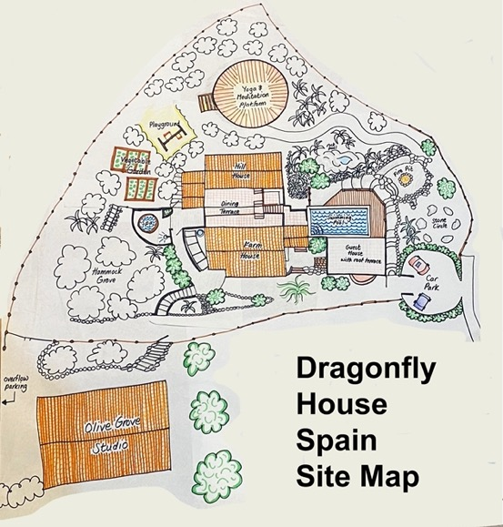

13. Floor Plans and Bedroom Descriptions

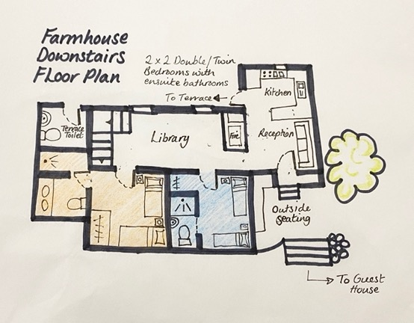

Alhambra Bedroom (Blue area on plan)
Location: Downstairs, off the library
Beds: 2 single beds (80cm by 180cm) or 1 double bed (160cm by 180cm)
Ensuite: Shower, toilet, sink, small and perfectly formed.
Suitable for: Guests happy to be in the middle of things, not advisable for physically larger guests.
Closet: Open hanging rail with shoe bench and large shelf, full length mirror.
Views: Over olive grove at sunset.

Olive Tree Bedroom (Orange area on plan)
Location: Downstairs, off the library
Beds: 2 single beds (90cm by 190cm) or 1 super king size bed (180cm by 190cm)
Ensuite: Large walk-in shower, toilet, double sinks.
Suitable for: Guests happy to be in the middle of things.
Closet: Wardrobe and dressing table, full length mirror.
Views: Over olive grove at sunset.

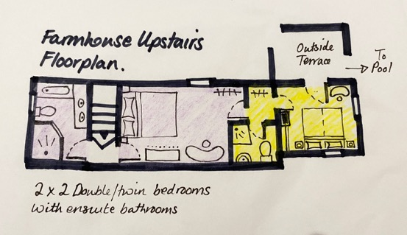

Angels Rest Bedroom: Purple area on floor plan
Location: Upstairs from the library
Beds: One king-sized rococo style bed fit for a princess or two (180cm by 190cm)
Separate bathroom: Large walk-in shower, toilet, double sinks and bathtub.
Suitable for: Guests who like to feel pampered.
Closet: Open hanging rail with shoe bench, dressing table, chest of drawers, full length mirror.
Views: Out to the dining terrace.

Almond Blossom Bedroom: Yellow area on floor plan
Location: Upstairs above the Farmhouse kitchen, directly next to the swimming pool.
Beds: 2 single beds (90cm by 190cm) or 1 super king size bed (180cm by 190cm)
Ensuite bathroom: Shower, toilet, exquisite sink.
Suitable for: Guests who like to see the countryside from every angle in their room.
Separate walk-in closet: Open hanging rail with shoe bench, dressing table, full length mirror.
Views: Triple aspect with views of sunrise, swimming pool and sunset.

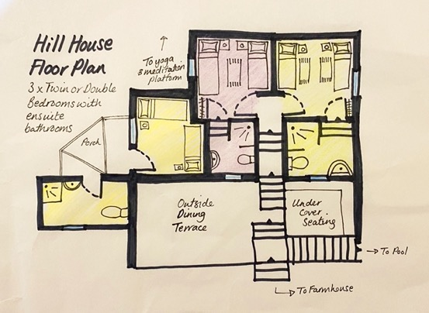

Mountain View Bedroom: Green area on floor plan
Location: Upstairs behind the main dining terrace on the right.
Beds: 2 single beds (90cm by 190cm) or 1 super king size bed (180cm by 190cm)
Ensuite bathroom: Shower, toilet, sink.
Suitable for: Guests who prefer to be a little away from the crowd.
Closet: Open hanging rail with shoe bench, full length mirror.
Views: Views of sunset over the mountain and swimming pool.

Swallows Nest Bedroom: Purple area on floor plan
Location: Upstairs behind the main dining terrace on the left.
Beds: 2 single beds (90cm by 190cm) or 1 super king size bed (180cm by 190cm)
Ensuite bathroom: Shower, toilet, sink.
Suitable for: Guests who prefer to be a little away from the crowd.
Closet: Open hanging rail with shoe bench, full length mirror.
Views: Views of sunrise over the olive grove.

Fig Tree Bedroom: Yellow area on floor plan
Location: Around to the back left of the Hill house.
Beds: 2 single beds (90cm by 180cm) or 1 king size bed (180cm by 180cm)
Separate bathroom: Shower, toilet, sink. Accessed outside of the bedroom.
Suitable for: Guests who prefer to be more separate from the group.
Closet: Open hanging rail with shoe bench, full length mirror.
Views: Views of sunrise over the olive grove.
Terrace: Access to private rustic terrace.

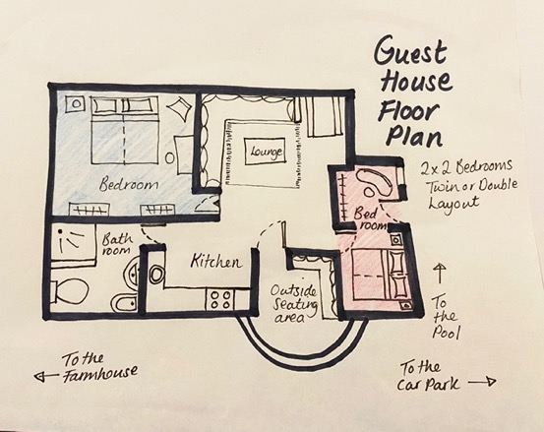

Dragonfly Bedroom: Blue area on floor plan
Location: Left side within the Guest house.
Beds: 2 single beds (90cm by 190cm) or 1 super king size bed (180cm by 190cm)
Separate shared bathroom: Moroccan style, shower, toilet, sink, bidet.
Suitable for: Guests who prefer to be separate from the group and don’t mind sharing a bathroom.
Closet: 2 x open hanging rails with 2 x shoe benches, full length mirror, dressing table.
Views: Views of sunset and ancient almond tree.
Specific use of: Guest house terrace, lounge and kitchen.

Butterfly Bedroom: Pink area on floor plan
Location: Right side within the Guest house. Closest room to car park and entrance.
Arrangement: Two adjoining rooms that can be arranged as two separate single bedrooms or a double room with dressing room.
Beds: 2 single beds (80cm by 180cm) or 1 double bed (160cm by 180cm)
Separate shared bathroom: Moroccan style, shower, toilet, sink, bidet.
Suitable for: Guests who prefer to be separate from the group and don’t mind sharing a bathroom.
Closet: 2 x open hanging rails with 2 x shoe benches, full length mirror, dressing table.
Views: Views of sunset over the olive grove.
Specific use of: Guest house terrace, lounge and kitchen.

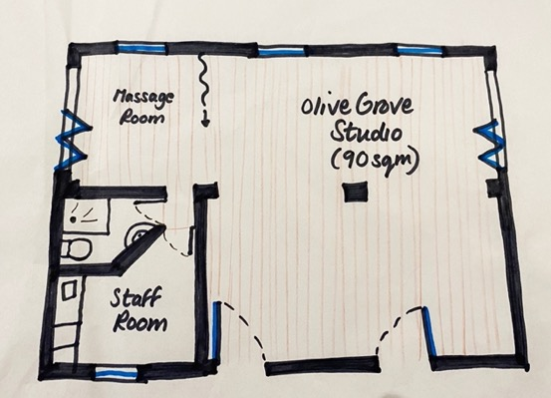

75 square metres of clear space for yoga, art, dance, meditation and more.

270-degree views across the olive groves.

2 large bi-fold doors open the space to increase flow of air and merge with nature.

Massage space can be separated by a curtain.

From autumn 2022:

- Shower room with toilet and sink is accessible from inside the studio

If you have any queries or requests, please contact us at: helen@casalibelulaespana.com

14. Dragonfly Retreat Guest Form

Suggested form, ideally completed by retreat participants online or emailed to helen@casalibelulaespana.com around 1 week in advance of the retreat.

https://forms.gle/BEF9Htrb9zjYPgBm9

We believe strongly we can only ever be responsible for ourselves, and our essential condition of you staying with us is that you follow this principle too.

In choosing to stay with us, you are agreeing to be fully responsible and legally liable for your actions, words, physical well-being, medical health, safety, treatment of Dragonfly House, respect for each other and your possessions whilst staying with us.

The purpose of this form is for us to collect the information we need to support you and nourish you well while you stay with us. We are outside of town and a long way to the nearest shop so the more you let us know, the more we can make sure we have in stock what you need.

All questions are totally optional, the more information you choose to give us the more we can connect with you energetically before you arrive and plan your menu and how we set up the space for your greatest comfort.

- Please tell us your full name:

- Please tell us the best email address for you:

- Please tell us your date of birth:

- Please let us know where you are travelling to us from and your nationality if you wish:

- Please let us know who to contact in an emergency and how best to reach them:

- If you have any medical or health conditions that we should be aware of please tell us about them here, include details of any essential medication, recent operations, and pregnancies if you feel relevant:

- If you have any food preferences, restrictions, intolerances or allergies please tell us – be really specific, let us know what you need:

- Please let us know if your movement or mobility is restricted in any way?

- Is there anything else you know you need to feel comfortable while staying with us?

Thank you from the Dragonfly House Team.
We are looking forward to welcoming you soon!

